The Parish of Crail and St Ayle
Reflections for the church of the moment, from Rev John Murray
Sunday 23rd August 2020
Grace and peace from God the Father and the Lord Jesus Christ

Lord, in this time of worship may we know who we are, and who you are, and discern our gifts in the body of Christ.

‘Be still and know that I am God’: The risen Christ present with us by the Spirit is our ‘temple’, our true and lasting place of worship

Today, our readings are about names and nature, and acting out of our true new identity in God. Who are you? More than a name, a place in a family circle, or a role in life. May we let God be God to us, and may we know that God loves us as we are.

Matthew 16:13-18 When Jesus came to the region of Caesarea Philippi, he asked his disciples, "Who do people say the Son of Man is?" They replied, "Some say John the Baptist; others say Elijah; and still others, Jeremiah or one of the prophets." "But what about you?" he asked. "Who do you say I am?" Simon Peter answered, "You are the Messiah, the Son of the living God." Jesus replied, "Blessed are you, Simon son of Jonah, for this was not revealed to you by flesh and blood, but by my Father in heaven. And I tell you that you are Peter, and on this rock I will build my church, and the gates of Hades will not overcome it.

Romans 12:1-8 Therefore, I urge you, brothers and sisters, in view of God’s mercy, to offer your bodies as a living sacrifice, holy and pleasing to God—this is your true and proper worship. Do not conform to the pattern of this world, but be transformed by the renewing of your mind. Then you will be able to test and approve what God’s will is—his good, pleasing and perfect will. For by the grace given me I say to every one of you: Do not think of yourself more highly than you ought, but rather think of yourself with sober judgment, in accordance with the faith God has distributed to each of you. For just as each of us has one body with many members, and these members do not all have the same function, so in Christ we, though many, form one body, and each member belongs to all the others.

The Lord’s Prayer
Our Father, who art in heaven, hallowed be thy name. Thy kingdom come, thy will be done, on earth as it is in heaven. Give us this day our daily bread. And forgive us our debts, as we forgive our debtors. And lead us not into temptation, but deliver us from evil. For thine is the kingdom, and the power, and the glory, forever

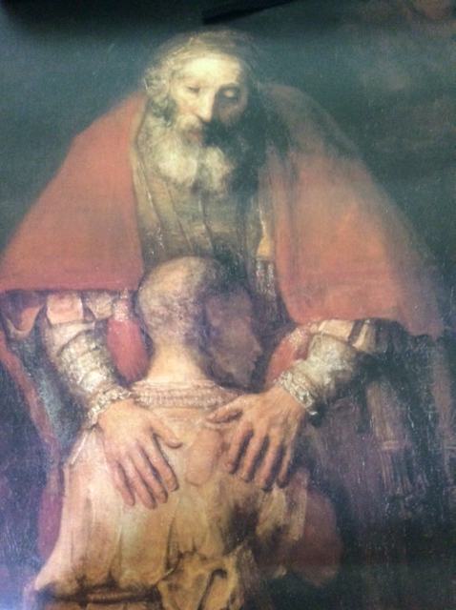
Rembrandt: the prodigal son
Finding God we find ourselves

Our two readings today go hand in hand. The location of Caesarea Phillipi, scene of the Matthew passage, is up in the north of Israel, where the springs of the Jordan, create the river which brings life to the dry arid land. And that’s a picture for how realisation of these truths, knowing who God is, and knowing who we truly are, can bring life to us as we let their power flow through us.
The Matthew text asks each one of us to think hard about who Jesus is, and then when we feel ready, articulate that truth on our lips. Jesus knew who he was, but wanted the disciples to think hard about the question, and then tell him. And Jesus, and his Father delight when we say, as the Christian faith invites us to say, ‘You are the Messiah, the son of the living God! Refreshing words that give us life, and give Jesus his worth and true value.
And the reading from Romans finds Paul telling the church how they should act in the light of who Jesus is: we are to offer ourselves to him and to God the Father through the Spirit, and as we live that out, we will be transformed, not in an external cosmetic way but in the renewing of our minds. New minds give new thoughts, new actions.
Consider this picture by Rembrandt. The father and son are at one: each has found out who they are and are at peace: it took some time and pain: yet all is now well. A new life is beginning.
Prayers

Lord, in the light of who you are, we come with our prayers, we come as different ‘’I am’s’’, to you the great I AM. We don’t know how to pray, but the Spirit helps us.

Lord, you know all things, and yet you ask us to articulate what we think about you, and this is our worship. As a parent delights to hear their child’s first ‘speech’, so you delight to hear our attempts at communication, and we pray as we can, not as we can’t. Hear us, as we come as we are, praying to be the people you see we can be.

God who created us, we come to say that you are LORD, our Lord. We are more than flesh and blood. We are created in you, and our chief purpose is to enjoy you and to give you glory. Pardon all within us that does not do that, and renew our minds we pray, transforming us into those who are useful and happy members of the body of Christ. We pray as church that we would be re-awakened in this time of ‘exile’, to see afresh and share the transformational power of the gospel in a generation which knows so little about Christian faith.
Today, as August draws on, we remember the cycles which thankfully remain, of the harvest of land and sea, of community life. And we pray for where harvests have failed, and community life is fractured, for those affected by floods and drought, where the future looks bleak. For those who are working to keep food banks going, and providing safety nets for many. Help us to be generous and thoughtful givers of all you have given us.
We pray for countries of unrest, and for places where instability and tension are bubbling. May peace and wise words be to the fore, and we pray for our political leaders at this time. May you be with our children and school and nursery staff in this new term which has started amidst such challenging circumstances. We pray for those who grieve loss of one sort or another
And in this coming week abide with us, granting us peace and joy, that we may be salt and light.
And hear these our silent prayers... Amen

Blessing

Go with confidence into the days ahead,
Trusting in God’s unfailing love and faithfulness.
God will not abandon you, for you are the work of his hands – his own creation –
And his love endures forever. So go in joy to love and serve the Lord!

Reflections for the week: living in the moment

We all know about Moses and about how (after God led him from his self-imposed exile), he led the Jews from exile into the promised land. And about how years later again the Jews again went into exile. And as they came back from Babylon, they had learned lessons and gained a fresh understanding of God’s goodness. In some ways this time of lockdown and returning to ‘normal’ can seem like a time of exile, and return from exile. Therefore it is good to reflect on what God is asking us to learn from this theme of returning from exile: what should we leave behind and what have we learnt, in terms of ourselves and as to being church together?

Ps 126: when the Lord brought back the captives to Zion, we were like people who dreamed. Our mouths were filled with laughter, our tongues with songs of joy. (how we all long to be back singing together!). Remember the Kirk Sessions of Crail (on Tuesday) and St Ayle (on Monday), as they meet this week to discuss the issue of the possible re-opening of church buildings.

View from the manse

We can learn a lot from nature: when we came at the end of July, the field at the back of the manse was waving crops: then it was cut, and now it is ploughed. A lesson in impermanence. Would we ever think it should remain the same for ever? We are to learn in our lives to anticipate and welcome change in our lives. Imagine if time really stood still!

Live in the moment, minute by minute The Lord says: when you live in the past, it is hard: when you live in the future it is hard: when you live in the moment, it is not hard. I am here; my name is I AM

Change is in the natural order of things: to everything there is a season.

Wish peace

The Jewish word for peace is ‘shalom’. It speaks of a deep health and wellbeing that is a daily greeting. Think about and/or greet someone today with ‘shalom’, and wish peace into their life.

…. And do not worry about your life (Matthew 6:25)

Often we can wonder and unduly worry about the future: Ps 138v.8 tells us this: ‘The LORD will fulfil his purpose for me; your love, O LORD, endures for ever’. Let’s enter more into this promise this week.

