The Parishes of Crail and St Ayle
Reflections for the Locked out - Locked Down Church from Peter Neilson
Sunday 7 June 2020
Good morning and shalom to all my friends in Crail and St Ayle.
Grace and peace to you from God the Father and our Lord Jesus Christ.
When I was writing about Pentecost’s challenge to racism in the middle of last week, I did not anticipate the eruption of protest across the USA over the murder of George Floyd, so reminiscent of the Civil Rights struggle of the 1960’s. Let us pray that a new moral leadership emerges that can make true peace built on justice, rather than try to keep a false peace based on further oppression.
Today I have decided to set aside my personal reflections, and share with you the thoughts of a friend from our Macedonian Ministry Staff, Adam Mixon, an African-American pastor in Birmingham, Alabama, the scene of Civil Rights protests in 1963.
I have been deeply distressed by the scenes on our TV screens, but feel I do not have the right to comment from the comfort of my place of privilege. I invite us all to listen to the struggles of a man who is wrestling with his response to what is happening, and offering moral and spiritual leadership to his people and to fellow pastors across the States – our brothers and sisters in Christ.
We will come to his words in due course. So take time to settle, with music, candle, Bible and whatever you need for this time of worship. We are “alone together” in the company of “Our Father” and all his multi-coloured family.
We begin with the Celtic Caim, inviting God to encircle us wherever we are.
Gathering into the Presence of God

The Celtic Caim
The prayer of encircling – a prayer of presence and protection

Imagine a circle round yourself.
God is with you in the circle.
God our Father, keep faith in and doubt out.

Imagine a circle round us as a household/church family.
God is with us in the circle.
Jesus, Son of God, keep love in and fear out.

Imagine a circle round a person for whom you are concerned today.
God is with them in the circle.
Holy Spirit of God, keep hope in and despair out.

Imagine a circle round the planet earth – in all its beauty and tragedy.
God is with us in the circle.
Father, Son and Holy Spirit, our God, keep goodness in and evil out.

In the name of Jesus, who is Emmanuel, God with us. AMEN.

Listening for God’s Word
During our last Macedonian Ministry trip to The Holy Land, I remember standing with friends from North Dakota on the Mount of Beatitudes. Instead of reading the familiar passage, each person spoke out from memory one phrase as a blessing: “Blessed are you......”
Each of us in turn received the blessing that rested on our hearts, and listened to the affirmation that we were – amazingly – commissioned to be the salt of the earth and the light of the world.
Take time to read these familiar words. Receive the blessing you need to hear. Consider what it means for you to be salt and light where you are in this strange season.
Read: Matthew 5:1-16
Reflecting on God’s Word

Peace-Making is Not Peace-Keeping

by: Adam Mixon I June 2, 2020

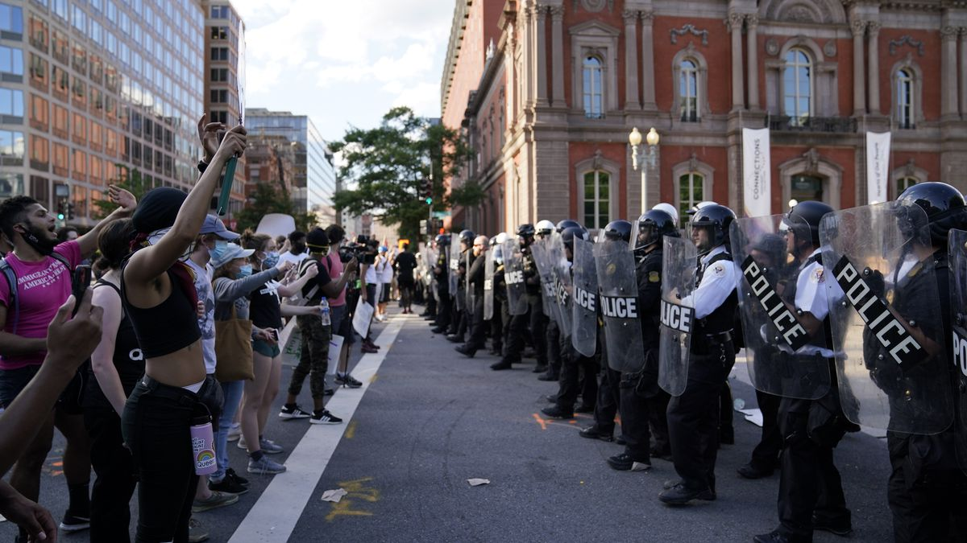

To assume that peace exists or can be maintained simply by remaining silent, is a misrepresentation of what peace is. To remain silent in the face of oppression or violence, is not “peace,” and that silence is not “golden.” This false peace is more akin to complicity and cowardice, and this silence is “yellow.” Do you understand?
False peace must be broken so that true peace can be made. Superficial sanctimony and shallow genteelness are nothing more than masks for an uneasy and counterfeit peace. This repressive, passive-aggressive, counterfeit peace leaves wounds festering that eventually erupt in blistering outbreaks of violence (physical and verbal) and discord. This false peace, in our culture, is often what is weaponized against oppressed peoples in the name of civility. This is not the peace that God gives us, and this is not the virtue required of us as God’s people. This is not an outworking of the “fruit of the Spirit.” This is rotten fruit from a corrupt tree – this is a distortion and a deception.
The peace we have with God through Christ, demands that we are in His presence. God’s presence is everywhere, there’s no place we can go where God is not, but peace comes from more than just a casual realization of divine presence. Peace comes when we submit to His presence and yield to His grace and guidance. When we operate from a posture of balance and well-being - a position of courageous grace, a position of dignity and love, and a position of integrity and honesty, our aim is to make peace. But when our aim is model the Kingdom of God in this fallen world, we are also necessarily compelled to break uneasy and false peace, to call out injustices and hypocrisy, and to do so with the dignity with which Christ called out injustice and hypocrisy among both religious and civil authorities!
Jesus, who is the Prince of Peace, was crucified by Roman authorities at the behest of Jewish religious leadership. This point must never be lost. Much like the prophets of our own times – murdered for disturbing and disrupting this false peace - Jesus died horribly and publicly in order to restore true peace between God and humanity. False peace was broken so true peace could be restored. Can I say it again?
Peace-making is not the equivalent of peacekeeping.
Now, I want to focus briefly, on how we maintain a posture of peace – peace that surpasses understanding – in a culture that sates itself on violence and destruction.
How do we keep a right mind and a pure heart, when everything around us smacks of oppression and injustice, malice and unfairness?
How do we remain a hopeful outlook and a steady resolve, when we are surrounded by wickedness and corruption?
Brothers and Sisters, we must stay before God. We must stem our exposure to the negative influences of the world and guard our hearts against bitterness (this is for both self-care and compassion’s sake). Frustration and anxiety will lead to a type of desperation that would have us assume the ways of those who oppress and harm us. We must not give into this darkness. We must stay in the light of His love and draw on His grace and power to remain as peaceful warriors protesting and disrupting the false peace that is really no peace at all!
We must abide in the presence of God. We must acknowledge His presence and then yield to His presence. This is difficult, I am a witness, when we are angry and offended, marginalized and victimized, but this is the posture that we must maintain as God’s people. We cannot do this in our own strength, hence the constant reminders in Scripture that we remain in His presence – no matter what! He will keep us in perfect peace, when our minds are stayed on Him!
³ You keep him in perfect peace
whose mind is stayed on you,
because he trusts in you. (Isaiah 26:3)
Brothers and Sisters, when we abide in Him, He will strengthen us amid life’s challenges, afflictions, tragedies, and injustices. We, as we remain in Him, must be able to draw on this gracious fountain that never runs dry. Our hope will remain secure, our joy will persist, and our peace will surpass understanding. We will have the strength we need to maintain our dignity, to keep standing up, and sitting down, to keep protesting the wicked and oppressive forces that would destroy us. We will draw from the wellspring of God’s Spirit and find the resolve to keep pressing, to keep marching, to keep singing, to keep praying, to keep serving, and to keep loving others. We must be salt and light. We cannot remain silent – we must not exercise this right. We must be counted among those whom Jesus himself declared:
⁹ “Blessed are the peacemakers, for they shall be called sons of God. (Matthew 5:9)
False peace must be broken, so that true peace can be restored. We must disturb and disrupt with the dignity that reflects the image of Christ and emphatically declares the justice of God.

Responding to God’s Word and God’s Spirit
Lord Jesus Christ, Prince of Peace
Forgive us our complacency
Our easy acceptance of the false peace
Our security bought by the oppression of others.
Lord, in your mercy,
Hear our prayer.

Lord Jesus Christ, Prince of Peace
Raise up prophets of peace
Who do justice, love mercy
And walk humbly with God.
Lord, in your mercy,
Hear our prayer.

Lord Jesus Christ, Prince of Peace
Lead world leaders into your wisdom
To look beyond their blinkered vision
And see new horizons of Divine possibility.
Lord, in your mercy,
Hear our prayer.

Lord Jesus Christ, Prince of Peace
In this season of anxiety
Over health, work and livelihoods
Give your peace that is beyond understanding.
Lord, in your mercy,
Hear our prayer.

Lord Jesus Christ, Prince of Peace
In homes where there is family tension
Living with abuse and fear
Send the soothing balm of your Spirit.
Lord, in your mercy,
Hear our prayer.

Lord Jesus Christ, Prince of Peace
For those who come to mind
And those who are constantly on our hearts
Grant grace sufficient for their every need.
Lord, in your mercy,
Hear our prayer. AMEN

A Meditation Before we Go
A Friendship Blessing
May you be blessed with good friends
May you learn to be a good friend to yourself.
May you be able to journey to that place in your soul
where there is great love, warmth, feeling and forgiveness.

May this change you.
May it transfigure that which is negative, distant and cold in you.
May you be brought in to the real passion, kinship and affinity of belonging.

May you treasure your friends.
May you be good to them, and may you be there for them;
may they bring you all the blessings, challenges, truth and light
that you need for your journey.

May you never be isolated;
but may you always be in the gentle nest
of belonging with your anam cara. ( Note: Anam Cara means Soul Friend)
{Anam Cara: Spiritual Wisdom from the Celtic World, John O’Donohue, Bantam Books, 1999 ]

A Blessing
As we say the blessing today, extend it to our brothers and sisters caught up in racial tension.
Go forth into the world in peace
Be of good courage
Hold fast that which is good
Render to no one evil for evil
Strengthen the fainthearted
Support the weak
Help the afflicted
Honour all people
Love and serve the Lord
Rejoicing in the power of the Holy Spirit
And the blessing of God almighty
The Father, the Son and the Holy Ghost
Be among you and remain with you forever
AMEN

