The Parishes of Crail and St Ayle
Reflections for the church of the moment, from Rev John Murray
Sunday 16th August 2020
Grace and peace from God the Father and the Lord Jesus Christ

Lord, in this time of worship may we be nourished with food from your table

‘Be still and know that I am God’: The risen Christ present with us by the Spirit is our ‘temple’, our true and lasting place of worship
Today, our readings are about people who are ‘different’ in some way, being included and being blessed and becoming blessings.

The Faith of a Canaanite Woman: Matthew 15:21-28
²¹ Leaving that place, Jesus withdrew to the region of Tyre and Sidon. ²² A Canaanite woman from that vicinity came to him, crying out, “Lord, Son of David, have mercy on me! My daughter is demon-possessed and suffering terribly.”²³ Jesus did not answer a word. So his disciples came to him and urged him, “Send her away, for she keeps crying out after us.”²⁴ He answered, “I was sent only to the lost sheep of Israel.”²⁵ The woman came and knelt before him. “Lord, help me!” she said.²⁶ He replied, “It is not right to take the children’s bread and toss it to the dogs.”²⁷ “Yes it is, Lord,” she said. “Even the dogs eat the crumbs that fall from their master’s table.”²⁸ Then Jesus said to her, “Woman, you have great faith! Your request is granted.” And her daughter was healed at that moment.
Gleanings and Leftovers: Ruth 2: 1-6
Ruth 2:1-6 ¹Now Naomi had a relative on her husband's side, a man of standing from the clan of Elimelek, whose name was Boaz. ²And Ruth the Moabite said to Naomi, "Let me go to the fields and pick up the leftover grain behind anyone in whose eyes I find favor." Naomi said to her, "Go ahead, my daughter." ³So she went out, entered a field and began to glean behind the harvesters. As it turned out, she was working in a field belonging to Boaz, who was from the clan of Elimelek. ⁴Just then Boaz arrived from Bethlehem and greeted the harvesters, "The LORD be with you!" "The LORD bless you!" they answered. ⁵Boaz asked the overseer of his harvesters, "Who does that young woman belong to?" ⁶The overseer replied, "She is the Moabite who came back from Moab with Naomi

The Lord’s Prayer
Our Father, who art in heaven, hallowed be thy name. Thy kingdom come, thy will be done, on earth as it is in heaven. Give us this day our daily bread. And forgive us our debts, as we forgive our debtors. And lead us not into temptation, but deliver us from evil. For thine is the kingdom, and the power, and the glory, forever

Oh crumbs! So little yet so much

It’s not looking good for these women at the beginning, but the stories move on and what wonderful endings. The woman from Canaan is tenacious, and gets a stunning endorsement from Jesus. The disciples were looking down on the woman just as the Pharisees looked down on them. Jesus had chided them earlier for their ‘little faith’, but Jesus tells the woman she has ‘great faith’ and her request is granted.
She just cares for her daughter and knows that Jesus can heal her: she’s asking for just a little teeny bit of his help. It seems that Jesus and God the Father respond to consistent cries to help - even willing in a sense to bring the future forward, as the ancient prophecies foretold that the Gentiles would also be blessed. What a great lesson for us in these difficult times: to keep going, looking to God to hear our prayers, and be with us in our daily walk: even when it feels we are alone.
And Ruth. Another lesson from someone who would have felt excluded and in a very weak position as she returned with mum-in-law to Bethlehem. Yet she became the great granny of King David. What an about turn!
These are stories where God’s kindness, and compassion, turn a situation around. We know there has been, and still is, much prejudice in the world, and even sadly at times in the church. Yet our God is full of kindness and compassion. Let us lean on, and sit and rest on that kindness this week, even as we sit on a chair or rest our heads on our pillows.
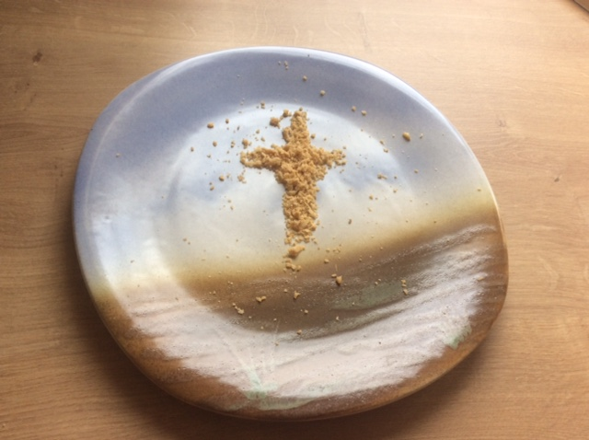

Prayers

Being a Church that is open to all people doesn’t happen by accident, but takes the whole body of Christ to commit to actively practising inclusion. This is hard and will sometimes mean asking difficult questions of ourselves, rethinking the way we’ve always done things and continually coming back to the bible and to prayer to rediscover how we live out our faith in this place and at this time. In doing this we become part of the ongoing story of the gospel going out to physical places and virtually: To the ends of the world and the internet, and all places in-between.

God you call us to praise, so let us be glad and sing for joy. Guide us in our worship this morning. Help us to be attentive to you as we come together as a community of faith to grow and learn, to be challenged and to be comforted.

Lord, the Great I AM, we confess that we are often weighed down by so much: our own darkness and misunderstandings, our compulsions, obsessions and desire to get our own way. Seeking your forgiveness, we hand all our burdens to you. So that, through the sacrifice of Jesus on the cross and his risen life, we might walk anew as your children.
God of Peace we pray for your church. For our parishes here, and throughout the land, worshipping and living out our callings day by day as you give us strength. For our brothers and sisters in Jesus around the world. Strengthen and encourage us Lord. Let your church shine out as a beacon, and may we together feel safe and secure, living in kindness and compassion. As we settle into new rhythms of life, we remember those who have suffered and are struggling with the effects of the last few months. Those who are barely coping and those who feel spent, with little left over; and those who are depending on crumbs of former resources. We pray for those in government leading us and who must make decisions in a fluid ever-changing situation. Lord, in these challenging days, may your will be done: may your kingdom come, Lord.
And in this coming week of prayer for church and country, may your Spirit move and inspire us: to pray out of kindness and compassion, and to keep on persevering in prayer, trusting in your kindness and compassion, through Christ Jesus our Lord, Amen
Blessing

May God be gracious to us and bless us. May God’s face shine upon us as we go out from here to make God’s ways known upon the earth to praise God in our homes and in our streets to bring God’s gladness and joy to our nations and neighbours. And so, may the blessing of God Almighty, Father, Son and Holy Spirit, be with us all, now and forevermore.

Reflections for the week: living in the moment

‘As it turned out’
Have a look again at the passage from Ruth. And see the lovely phrase there ‘as it turned out’. It just seemed by chance that Ruth happened to go to Boaz’s field, and truly, all the sadness in her and Naomi’s lives was tragic. Yet it is God, through all those times, who is moving these ladies’ stories along, with invisible kindness and compassion. The apostle Paul takes up these thoughts when he writes in Romans that ‘all things work together for good for those who love God’; and that it is really new life and new blessing, that is pushing up through the concrete of difficulty and sadness, as Job found out in all his troubles.
Take some moments to think about the truth of this in your own life, and perhaps in the life of your family.
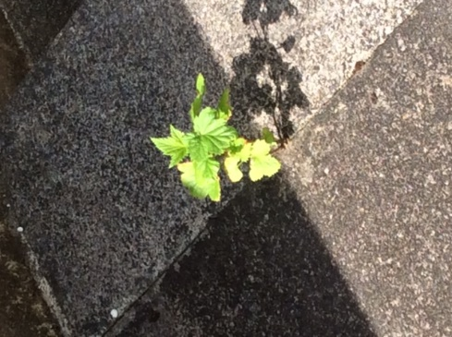
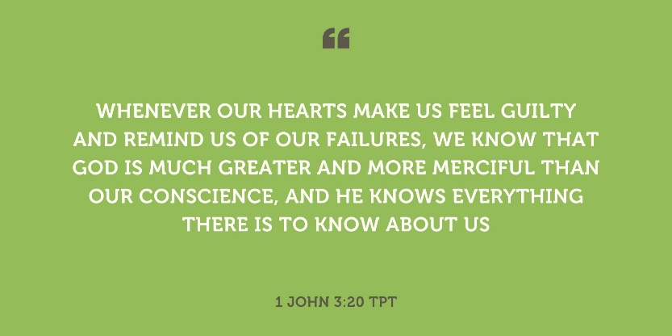

May our heads and hearts be a place where earth and heaven meet

Lord, allow more and more thoughts of your thinking to come into our hearts, day by day, till there shall be at last an open road between you and us, and your angels may go up and down amongst us, so that we may be in your heaven, even while we are upon your earth. Amen

Northumbria Community: adapted from a passage in David Elginbrod by George MacDonald

