The Parishes of Crail and St Ayle
Reflections for the church of the moment, from Rev John Murray
Sunday 26th July 2020
Grace and peace from God the Father and the Lord Jesus Christ

Lord, in this time of worship may our eyes be opened to see new treasure, our hearts enlarged to feel your living presence, and may we bask in your amazing grace.

‘Be still and know that I am God’: Become aware of God’s presence with you.

‘Seeing new things’ is our theme today. Seeing the things of value, and the things which are for our benefit, often in unlikely places. God wants us to search for such things, yet leaves it open to us to seek out and find out what is valuable in his kingdom. Paul invites us to see the good in the bad, and Jesus speaks of the treasure and the pearl to be seen in the midst of unpromising surroundings.

Romans 8:31-39

If God is for us, who can be against us? He who did not spare his own Son, but gave him up for us all—how will he not also, along with him, graciously give us all things? Who will bring any charge against those whom God has chosen? It is God who justifies. Who then is the one who condemns? No one. Christ Jesus who died—more than that, who was raised to life—is at the right hand of God and is also interceding for us. Who shall separate us from the love of Christ? Shall trouble or hardship or persecution or famine or nakedness or danger or sword? As it is written:
“For your sake we face death all day long;
we are considered as sheep to be slaughtered.”
No, in all these things we are more than conquerors through him who loved us. For I am convinced that neither death nor life, neither angels nor demons, neither the present nor the future, nor any powers, neither height nor depth, nor anything else in all creation, will be able to separate us from the love of God that is in Christ Jesus our Lord.

Matthew 13:44-46 "The kingdom of heaven is like treasure hidden in a field. When a man found it, he hid it again, and then in his joy went and sold all he had and bought that field. "Again, the kingdom of heaven is like a merchant looking for fine pearls. When he found one of great value, he went away and sold everything he had and bought it.

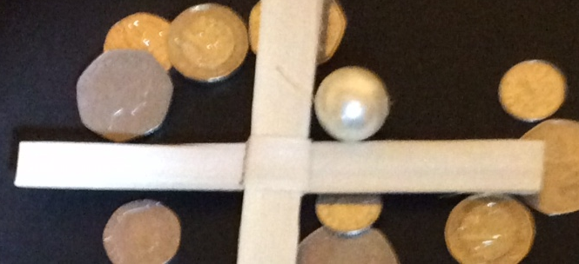

The Lord’s Prayer
Our Father, who art in heaven, hallowed be thy name. Thy kingdom come, thy will be done, on earth as it is in heaven. Give us this day our daily bread. And forgive us our debts, as we forgive our debtors. And lead us not into temptation, but deliver us from evil. For thine is the kingdom, and the power, and the glory, forever.

A treasure hunt

What do these passages have in common? They are teaching that in the mess of life, there are precious things to be found and appreciated. Jesus spoke in parables partly to teach people to think, and to look below the surface of things. I recall hearing years ago this verse:

“Two men looked out from prison bars,
One saw the mud, the other saw stars.”
1. Paul is telling us that with the help of his Spirit we are able to re-focus and see that ‘in all these things’ (trouble etc.), there is treasure to be found ( we are more than conquerors!). That is truly transformative.
2. And that Jesus in his death and resurrection, has achieved for us the verdict of ‘No condemnation’. With faith in the person and ministry of Christ, we have forgiveness and been raised to new life in the present.
3. That ‘nothing can separate us from the love of God’. You might have some real contrary things in your life right now, but we can trust God to use it for good. Christ is praying for us in these situations which otherwise would make us feel separated from him.
God wants us to be assured of these things, even as we plough on through the mud and mess of life. And finding things in muddy and odd places is exactly what Jesus is talking about with the treasure and the pearl of great price. It is wonderful to discover and see these things, yet we also need to do something about it, showing that we value what we have seen. There is a challenge here to see and to do.
Look at it this way: we believe that Jesus came down from heaven because God thinks we are treasure, and pearls of great price. As the apostle John said in his Gospel: John 3:16: ‘For God so loved the world, that he gave his one and only Son that whoever believes in him shall not perish but have eternal life.’ Jesus willingly lay down everything he had so that we could become his redeemed people.
It’s a fitting response from us then, to give him the same value in our lives, to take up or cross and follow him.

Prayers

Gracious, Loving God, We come this day to worship and praise you. To see you as you really are: glorious and beautiful, not some poor vision of our own making. You love the whole world in all its muddle and mess and you love us
Open our eyes to You, O God… may your Holy Spirit re–create us. Open our eyes, open our hearts, open our mouths in praise and worship and prayer.
Accept, O Lord, these gifts of our time, talents and treasure. However great or however small, may we be used to grow your kingdom. May we know the lasting treasure that we have in you, and help us to forever search and find you.
Lord Jesus Christ, we cannot express how thankful we are that you consider us your children. Although you were rich you became poor for us. In us, you saw your treasure, your pearl beyond all price. Words cannot express how grateful we are that nothing in our long list of things we fear, nothing can separate us from your love! Lord, we pray this day for all who are yet to hear this good news.
God of love and compassion, we pray for all who seek to make a difference in the lives of others. Be with carers and counsellors, medics and mediators, be with those with listening ears and those with caring hands. Be in all that opens people’s eyes to you. And with those who go to other countries to bring sight, to bring light pouring in to physical eyes. God of justice and peace, we pray for all who see and challenge injustices and stand up for what is right. Hear us and help us to see you this day, we pray. Amen

Blessing
May the grace of the Lord Jesus Christ, and the love of God and the fellowship of the Holy Spirit be with us all, evermore: Amen.

Thoughts for the week

The pure in heart shall see God. The seeing of Him will be the sign that we are like Him, for only by being like Him can we see Him as He is. But when we shall be fit to look Him in the face, God only knows. That is the heart of my hopes by day and my dreams by night. To behold the face of Jesus seems to me the one thing to be desired.

George MacDonald

Psalm 131

A song of ascents. Of David.
¹ My heart is not proud, Lord,
my eyes are not haughty;
I do not concern myself with great matters
or things too wonderful for me.
² But I have calmed and quieted myself,
I am like a weaned child with its mother;
like a weaned child I am content.
³ Israel, put your hope in the Lord
both now and forevermore.

What are your ‘great matters’ of which you need not concern yourself? Pray for God to help you see them. And then let them go!
