Maundy Thursday
Crail & St Ayle
9th April, 2020

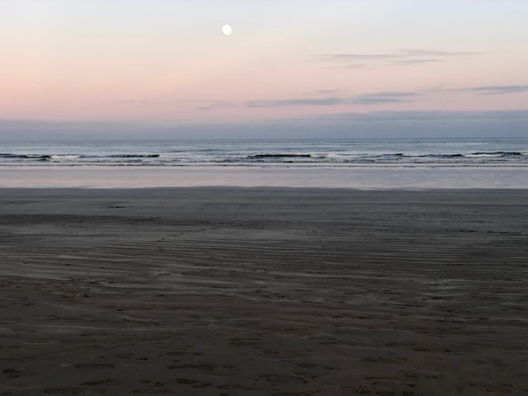

Yesterday began well enough
at the First Watch, but as the sun
rose the light seemed reluctant to dawn,
I mean in the usual way. And then it
happened.
I saw him look towards the fig tree and it
shrank in shame. He
took a step and a leaf
shivered to the ground - I
swear if there’d been an axe in his hand he’d have
laid it to it root and
fed the greedy fire. He told stories
glowering there of doing not talking, tales of
sacrifice, endeavour and
giving folk a fair go and
perish the ones who preen
and pray, who
take up valuable public space.

Today the sun glooms
in the sky. The land lies low.
Early, too early evening comes.

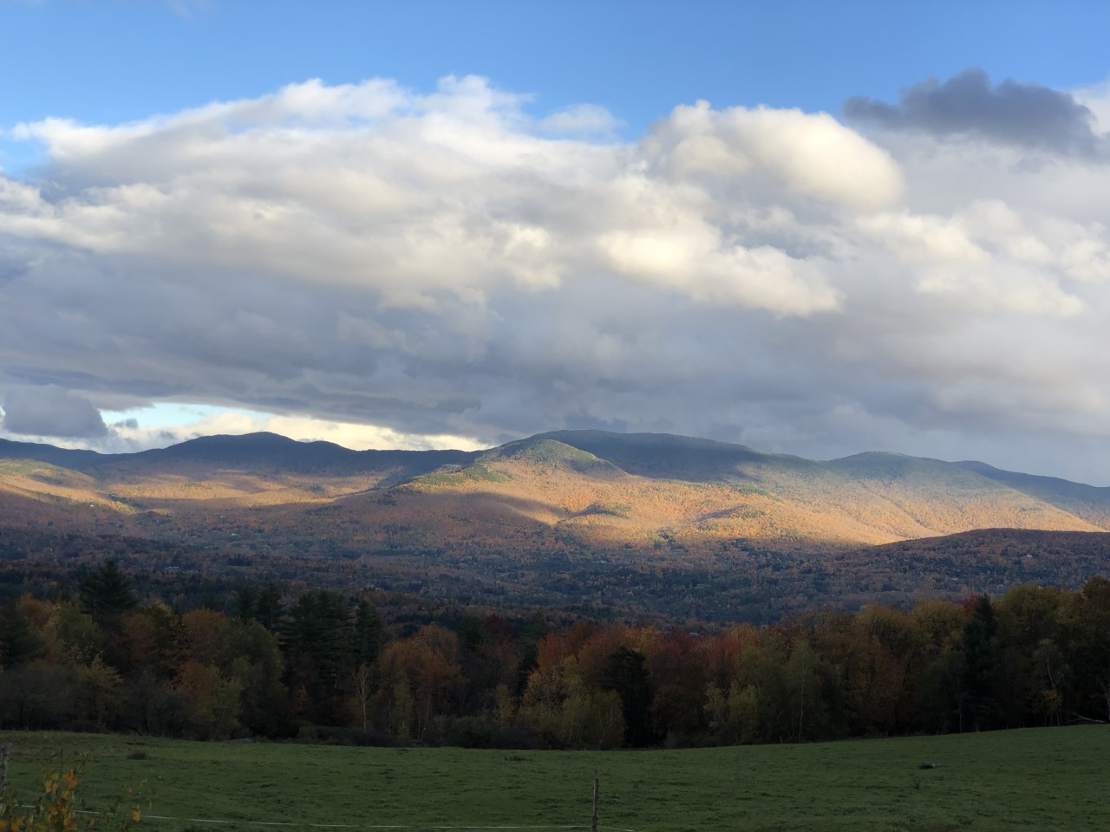

Call to Worship
Minister: When the lights are on, the house is full,
and the laughter is easy,

People of God: Behold, I stand at the door and knock.

Minister: When the lights are low and the house is still,
and the talk is intense, the air full of wondering,

People of God: Behold, I stand at the door and knock.

Minister: When the lights are out and the house is sad,
and voices are troubled,

People of God: Behold, I stand at the door and knock.

Minister: And tonight, always tonight,
as if there were no other people,
no other house,
no other door,

People of God: Behold, I stand at the door and knock.

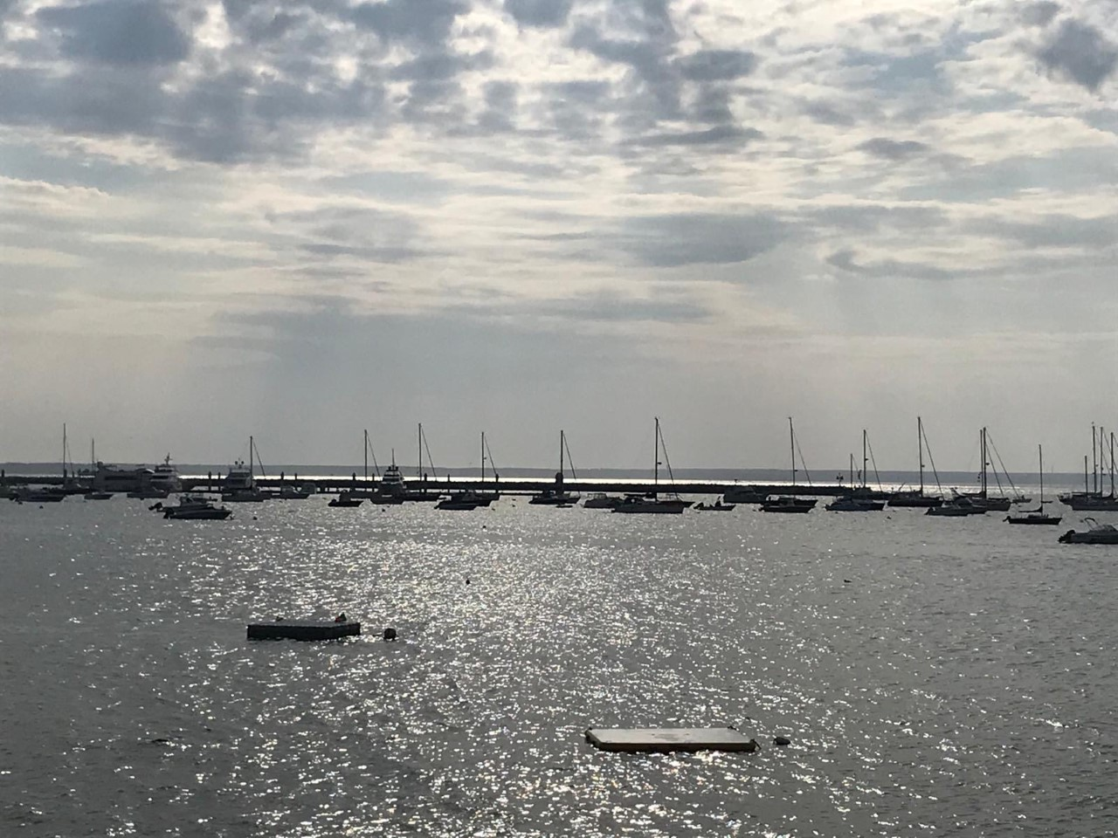

Prayers Approaching
Night-bound Lord
what terrors await?
You have drawn everything.
Nothing is surprising.
You have made it happen.
And you will die,
because of the world.

You are bound for darkness
the Light of the World heading headlong for execution
How will we see you, when you are, snuffed out?

A bowl, a towel, confusion
all is upside down as the master washes the feet of men
who would be friends to the end.
We watched in slow motion
a collision we couldn’t stop
a mugging we were helpless to prevent
a suffering we wishd we could do instead - almost.

But the shadowed world has brought the night
the gulf, the chasm, the yawning gap between God and humanity
is our doing.
Dark corners are gathering as easily as a curtain
is drawn against sunlight.
the gloom growls, grows and gathers
and any trace of a smile is doomed by frowning.
The Light of the World rises towards the deepest descending
and like frightened children we pray for morning light.

O Our Lord, what have we done?
Some things we know, others we don’t.
But now as Love massages our feet,
it occurs to us that we should have paid more attention
in these three years.

We take the bread and dip it, slipping into the night.

Hymn 376 ’Twas on that night when doomed to know

The Lord’s Prayer

I saw him wash his hands
and the room filled with gorgeous grape
and fresh-baked bread. Old wine skins
filled with new nectar bursting their seams.
The city trembled on the brink.

Our hearts were troubled.
The night fires lit and acrid smoke bore bitter gall.
But we were fed - at least
before fear killed the feast.
I will always remember that high room with
its clay lamps chinking
dark, dark corners, and the late sun darkling rose.

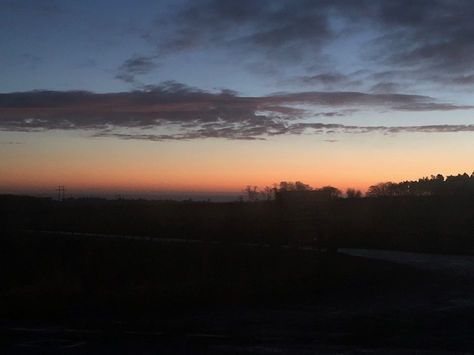
Hymn 374 From heaven you came, helpless babe

Scripture St John 13 vv 1 - 30

‘Crossing Over’

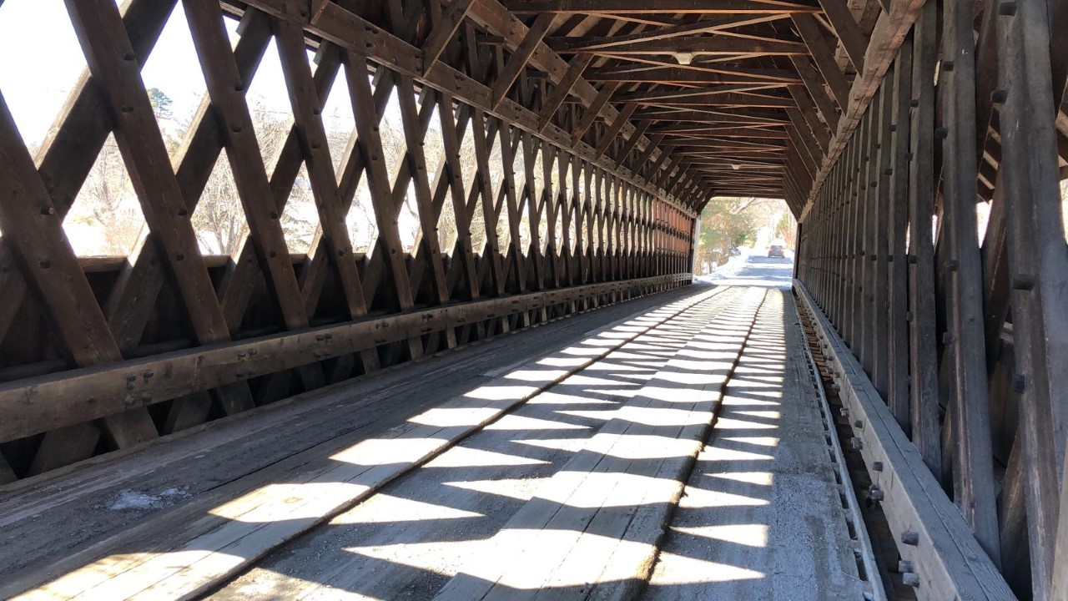

When our Prime Minister or Foreign Secretary visit British troops based far away from home in a foreign land they say they’re there to bridge the miles, to bring
messages of hope, reminders of love and assurances from home … they’re there to bring comfort from across a far distance across thousands of miles … and their
messages are meant as rallying calls - that despite being far away from loved ones … despite being in a hostile place they’re remembered and valued and people are
looking forward to their return …

Of course with technology advancing almost daily, messaging across the miles is
becoming easier whether it’s by WhatsApp, Instagram, Zoom or Skype … saying Hi and letting people know they’re remembered with love and affection across the miles is getting easier and easier …

Crossing nations and continents is, in this way getting easier, but the scripture we’ve
heard tonight reveals greater chasms than even these great divides - because running through John’s Gospel is a theme describing the crossing of enormous gulfs - and more than that, about crossing a spiritual gulf - a gulf which is man and woman made, which begins in the creation myth of Eden … and which has stretched wider and further and has distanced humanity more and more from the power we call God and Creator … Look at these words John writes,

… Jesus, knew that his hour had come to cross over (depart) from this Kosmos (world) and go to the Father …

Stephen Verney, an Anglican priest and theologian wrote this in his book on John’s gospel … Jesus, knows that his hour of destiny has come and that he must now cross over from one frontier into another … he must leave this world order of Kosmos and cross over to the Father - not some other state or world system - but to the
Father himself, in whose mind and heart this new world order exists …

Of course the Greek word Kosmos meant and means ‘the world’ but when John
mentions it, he’s using the word like a sort of theological pointing stick towards a very new world, in which a completely new order is running things … we call this new world order the Kingdom of God … so, I think what Stephen Verney means is that this isn’t a story about morale boosting heads of state crossing global
continents on good will missions … no, this is a story about the very human Jesus who shines as a refraction of the very light we call G-D, and in so wonderfully doing
opens up the astonishing understanding that he’s a glorious lynchpin opening souls to their Creator … and that his time for accomplishing this is fast approaching …

… In a moment which sends shivers down our spines John tells us, Jesus rose from the supper table … okay nothing too earth shattering in those words, until we
remember that all the way through his Gospel, John peppers his writing with the Greek verb Egere which means literally To rise … eventually John will use this verb Egere when he describes the memory, spirit and energy of Jesus rising above the bonds of death - so all the way through, John is leaving a paper-trail, a verb-trail even pointing always towards the climax of the Jesus story when Jesus Egere(s) on Easter morning … and now, here, on this night on this Maundy Thursday as we remember the foot washing event we’re signposted again as HE RISES from the supper table, and taking off his outer garment prepares to wash disciples’ feet … his rising is directly connected to servanthood, to the care of others … and what next? He pours out water into the basin which foreshadows the way he’ll pour himself out in courage and faithfulness against the evil in the world which is coming for him … Verney says in this action of pouring out the water, he’s showing how he will shortly pour his powerlessness out over cruel power in the world …

And there’s something else which is good to know from this rich passage … Stephen Verney reminds us that John tells us, having washed their feet Jesus wiped them with a towel … Wipe in Greek is Ekmassein from which comes our word Massage … It’s comforting to be massaged, isn't it … and John’s lovely use of this verb encourages a delightful image … because surely as Jesus massages their feet he’s relaxing and
reviving, refreshing and reinvigorating their whole selves … calling their troubled, tired souls from the heavy ties and burdens and sorrows of this world into a new way of being … Jesus, massages their feet, drawing them away from the things of the old world powers and calls them to follow him into the new life,
expectation and promise of the new Kosmos - a new world order when God is on the throne of the world, and every head of state knows it and is transfigured and altered into the ways of compassion, kindness, forgiveness and of course, love for all.

…. No wonder the power in the world killed him … world power will not
countenance challenge: It will kill you quick if it thinks you’re a threat.

So what we are saying? Surely that these apparently ordinary actions of Christ (rising from the supper table, pouring out water, rubbing/massaging friends’ feet) are
Kosmos crossing, new life promising, realm breaching gifts done by the human and divinely gifted Jesus in the presence of his friends and in service to them … and these offerings so simply made open the way of love to another
order, where God is on the throne of the world, and the pain of distance, separation, fracture, loss, division, bereavement, loneliness and isolation - all these horrors which so mark life in this world are felled … felled and fallen by Amazing Love which massages us into the new life of the Kingdom of God, and who fills us with
mysterious food so that we are nourished for the most amazing crossing we’ll ever make … such are the promises of God, and we see it with our own eyes, as he rises from table, pours out water and massages us, gentles us then fires us to do exactly the same … perhaps, then our invitation is to sense how we may make this timeless crossing, nourished as we are by the mysterious food of Maundy Thursday …

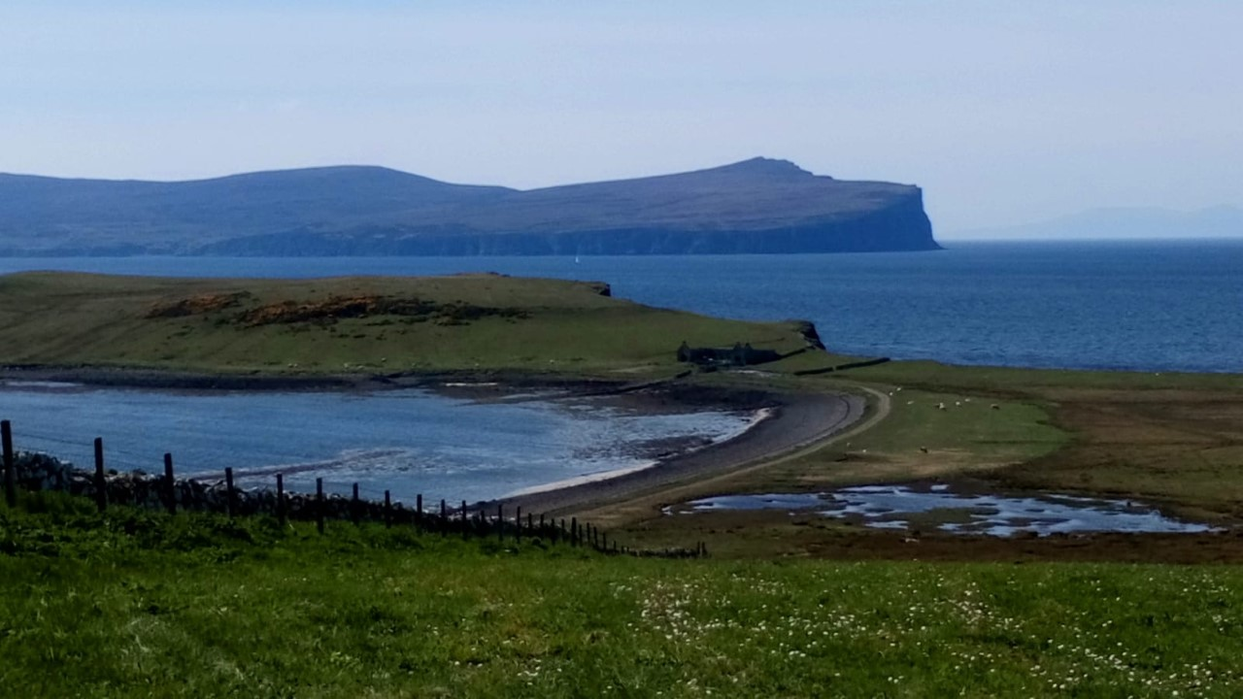
Hymn 378 Praise to the holiest in the height

Invitation to Communion

Affirmation of Faith, from The Iona Community
(Minister) We believe in Divinity with us,
Maker and sustainer of all life, of sun and moon, of water and earth,
of all human beings.

(People of God) We believe in God beside us,
Jesus Christ, the Word made flesh,
born of a woman, servant of the poor,
tortured and nailed to a tree.
A man of compassion, he died forsaken;
he descended into the earth
to the place of death.

On the third day he rose from the tomb;
he ascended into heaven
to be everywhere present;
and his Kingdom will come on earth.

We believe in God within us,
the Holy Spirit of Pentecostal fire,
life-giving breath for the Church,
Spirit of healing and forgiveness,
source of resurrection and life. Amen

Communion Hymn 661 Eat this bread

Introduction

The Great Prayer
M. The Lord be with you.

People of God : And also with you
M. Lift up your hearts

People of God: We lift them up to the Lord.

M. Let us give thanks to the Lord our God

People of God: It is right to give our thanks and praise.

Let us pray
Kosmos-Crossing Saviour
we acclaim you majestic in holiness, worthy of praise
worker of wonders.

In the beginning you created the Kosmos,
threw stars and dust into endless dark
and lit the furthest reaches of the universe with
galaxies’ light and nebula made of gas … you
rolled the stones of the earth
and made mountains
you breathed in and out
and caused the winds of earth to blow
you fashioned us as we might mould
clay figures and poured your breath
and wonder into us …you
gave us everything …

God in your mercy … hear our prayer …

But we knew best and stuck to our fears
and our determination to be god …
like frustrated children we pulled too hard
on the reins of our loving maker
until we severed the connection …

Even then you called us back and gave us
a Saviour, who in turn poured himself out for
us and rose in light, in defiance of our darkness …

The distance we forged couldn’t stand against
amazing love … you made the Tree of Death into
a symbol of hope through strife.
You raised up hope and re-drew the severed maps of
heaven and earth … and even now and always
you pray for the cosmos and our completion in you.

God in your mercy … hear our prayer …

In this promise and hope we therefore raise
up our voices, saying together the words of the Angels’ Hymn …

Sanctus
Holy, Holy, Holy Lord
God of power and might
Heaven and earth are full of your glory
Hosanna in the highest.
Blessed is he
who comes in the name of the Lord
Hosanna in the highest

On this night in which blessings and curses are abroad
we commend the fractured Cosmos to you, to your rising and your pouring out…
and in a moment’s quiet we remember the division in our world
and the distances we have cruelly unleashed … and in this dark hour we hand over the horrors of the Pandemic which is dividing and breaking us, and
pour our hearts’ longing into its leashing and demise …that we may rise, birthed
into health and new compassion …

… and now in the words of the Epiklesis I invoke the power of the
Holy Spirit to descend upon these gifts of bread and wine;
that they become transparently enough
the body and blood of your Son - that we
become his living body, loving and wombed for the world
until the dawning of the healed Cosmos …

… we say together the word of the Agnus dei (Lamb of God)

Agnus Dei
M: O Lamb of God, you take away the sin of the world,

People of God: Have mercy upon us.
M: O Lamb of God, you take away the sin of the world,

People of God: Have mercy upon us.
M: O Lamb of God, you take away the sin of the world,

People of God: Grant us your peace. Amen.

The Bread & Wine are shared for you, Beloved

* *

We have stood at the crossing of
worlds and we have made our choice.
By your grace
keep us through the watches of this fell night,
keep us awake as Gethsemane night gathers its darkness
which meets out the enduring enmity of Caesars to
stopper Love’s pouring.
As Judas hands over the One we say we love
the wheel of the world is in motion.
As its craven maw descends we hesitate as on a
high swinging bridge gripping the guard rails. So …

… what sort of crossing is this?

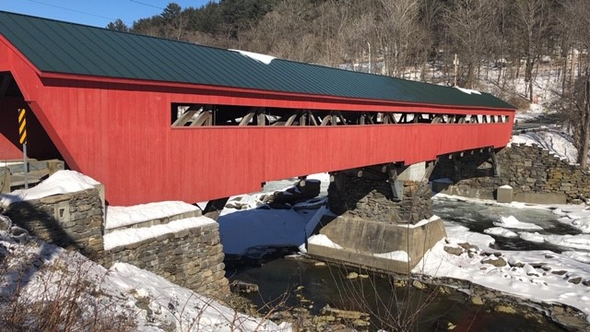

The arm of the Emperor is long, it has the power
to cross continents while the beaten rabbi
stumbles mere streets to reach his mean glory.
The might of Legions shake the earth, the glint
of their battle armour blinding, while canon and gas,
cluster bombs, land mines, genocide,
shock and awe paralyse all in poor appeasement.
They are impressive. So …

…what sort of crossing is this?

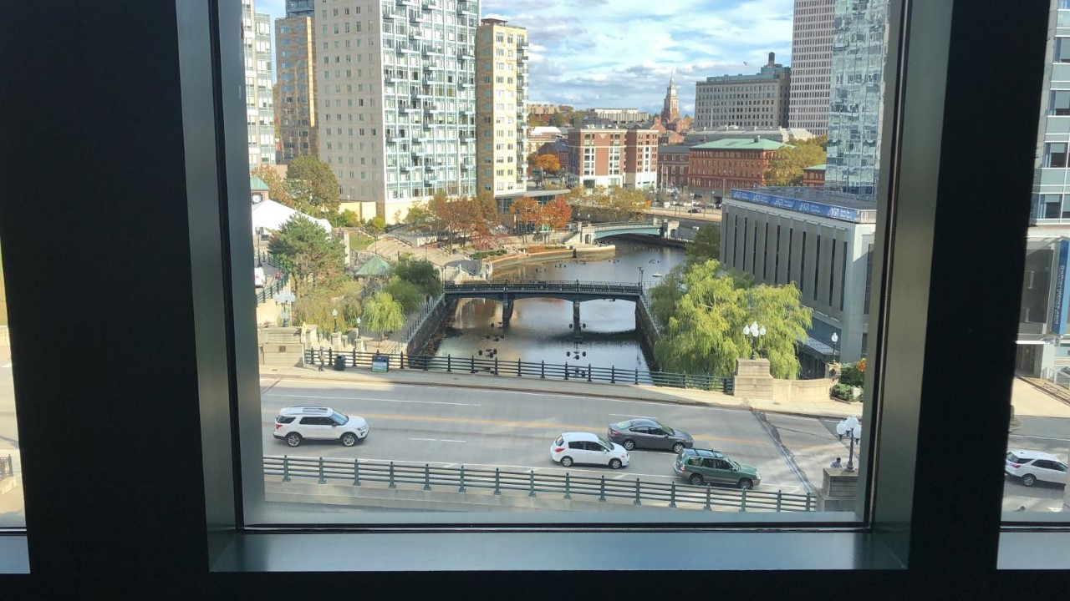

Inviting sign posts point their way
to tease us from our course. They open up
familiar paths. The Caesars
of ages and today, the gods of national security,
Economy, the nation state, spinning manifestos and
the press of a nuclear button are tangible, visible,
they make sense voiced from the mouths of their acolytes.
Their results are quicker than compassion, it’s easier to
make someone suffer, than to suffer with.

Dear God, Maker of Everything and Everyone -
What sort of crossing is this?

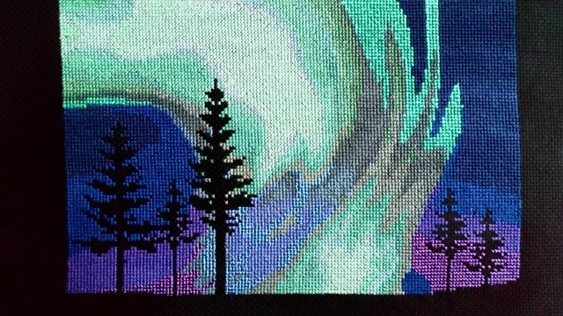

We Share The Peace
The Peace of our Lord Jesus Christ be with you

Hymn 375 This is the night, dear friends, the night for weeping

We go out, and it is night.

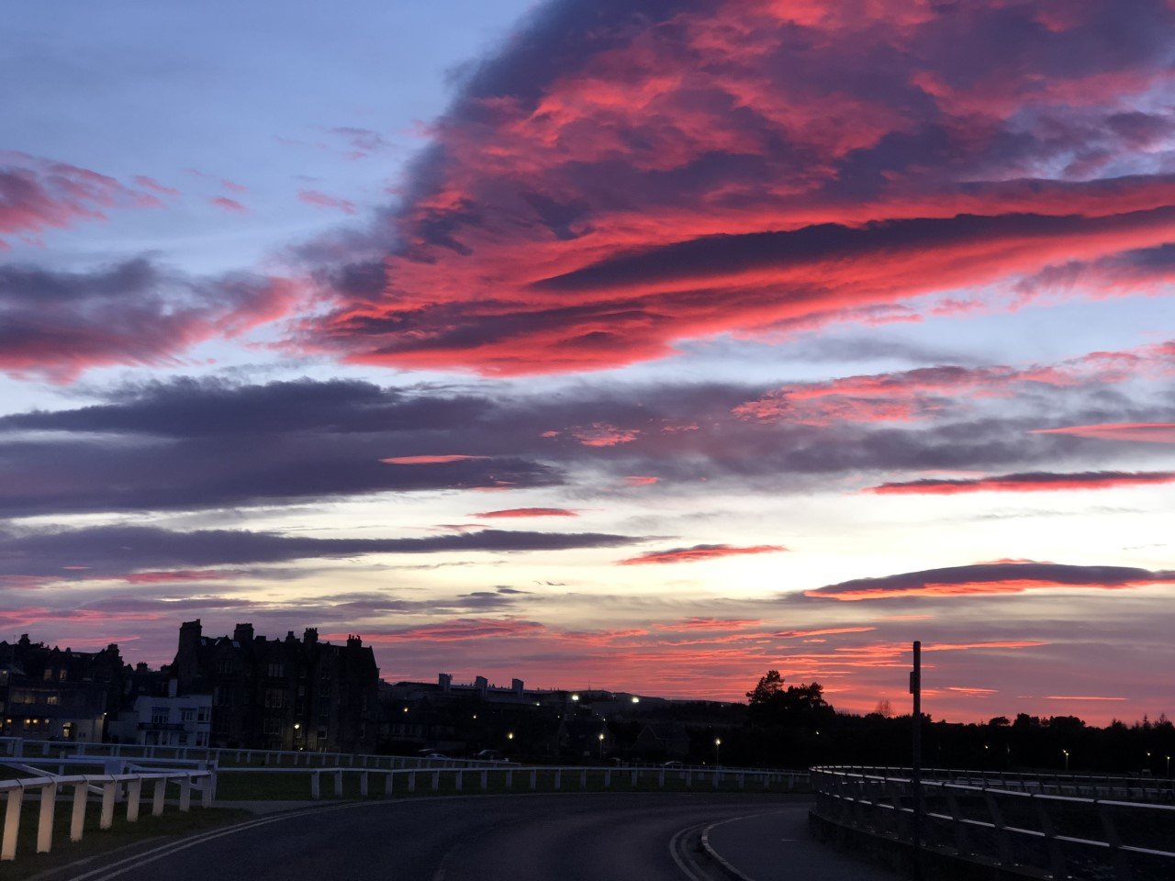

~ Afterword ~

‘The Kingdom’
by
R.S. Thomas

It’s a long way off but inside it
There are quite different things going on:
Festivals at which the poor man
Is king and the consumptive is
Healed; mirrors in which the blind look
At themselves and love looks at them
Back; and industry is for mending
The bent bones and the minds fractured
By life. It’s a long way off, but to get
There takes no time and admission
Is free, if you purge yourself
Of desire, and present yourself with
Your need only and the simple offering
Of your faith, green as a leaf.

